Data Analyst Internship-ApexPlanet Software Pvt. Ltd.
Executive Summary Report

This project involved analyzing the Sample Superstore dataset using Python, SQL, Power BI, and Machine Learning. The objective was to extract business insights, build dashboards, perform statistical analysis, and develop predictive models to support data-driven decision-making.

Tools Used:
- Python
- SQL (SQLite)
- Pandas
- NumPy
- Matplotlib
- Seaborn
- Plotly
- Power BI
- Scikit-learn

Dashboard Screenshort:
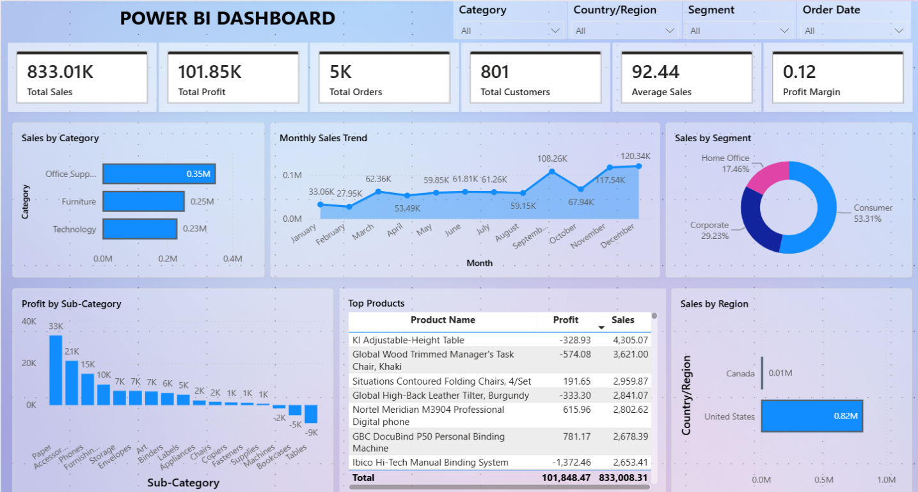
Top 5 Insights:
- Office Supplies generated the highest overall sales.
- Consumer customers contributed the highest sales.
- Higher discounts were associated with lower profitability.
- Sales showed noticeable monthly trends and seasonal fluctuations.
- Customer segmentation identified different purchasing behaviors.

Business Recommendations:
- Implement customer loyalty programs for high-value customers.
- Optimize discount policies to improve profitability.
- Use sales forecasting for better inventory planning.
Conclusion
This internship provided practical experience in data cleaning, SQL, data visualization, dashboard development, statistical analysis, and machine learning. The project demonstrates the ability to solve business problems using data analytics techniques.



